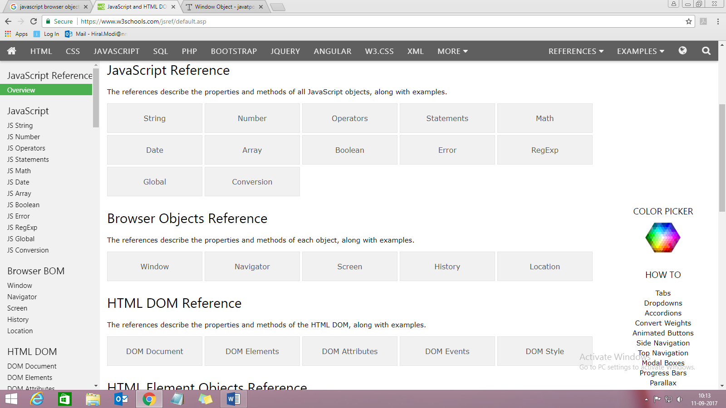

**Browser Object Model**

The **Browser Object Model** (BOM) is used to interact with the browser.

The **default object of browser is window** means you can call all the functions of window by specifying window or directly. For example:

1. window.alert("hello javascript");

is same as:

1. alert("hello javascript");

You can use a lot of properties (other objects) defined underneath the window object like document, history, screen, navigator, location

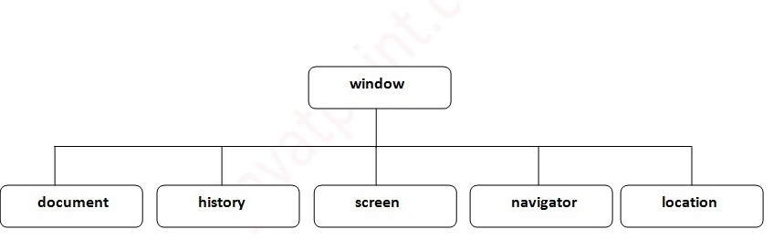

# Window Object

The **window object** represents an open window in browser. An object of window is created automatically by the browser.

#### Note: If a document contain frames (<iframe> tags), the browser creates one window object for the HTML document, and one additional window object for each frame.

## Methods of window object

The important methods of window object are as follows:

|  |  |
| --- | --- |
| **Method** | **Description** |
| alert() | displays the alert box containing message with ok button. |
| confirm() | displays the confirm dialog box containing message with ok and cancel button. |
| prompt() | displays a dialog box to get input from the user. |
| open() | opens the new window. |
| close() | closes the current window. |
| setTimeout() | performs action after specified time like calling function, evaluating expressions etc. |

Example of setTimeout() : It performs its task after the given milliseconds.

<script type="text/javascript">

function msg(){

setTimeout(

function(){

alert("Welcome to JavaScript after 2 seconds")

},2000);

}

</script>

<input type="button" value="click" onclick="msg()"/>

# History Object

The **JavaScript history object** represents an array of URLs visited by the user. By using this object, you can load previous, forward or any particular page.

The history object is the window property, so it can be accessed by:

window.history

Or

history

## Methods of history object

There are only 3 methods of history object.

|  |  |  |
| --- | --- | --- |
| **No.** | **Method** | **Description** |
| 1 | forward() | loads the next page. |
| 2 | back() | loads the previous page. |
| 3 | go() | loads the given page number. |

## Example of history object

Let’s see the different usage of history object.

1. history.back();//for previous page
2. history.forward();//for next page
3. history.go(2);//for next 2nd page
4. history.go(-2);//for previous 2nd page

# Navigator Object

The **JavaScript navigator object** is used for browser detection. It can be used to get browser information such as appName, appCodeName, userAgent etc.

The navigator object is the window property, so it can be accessed by:

window.navigator

Or

navigator

## Property of JavaScript navigator object

There are many properties of navigator object that returns information of the browser.

|  |  |  |
| --- | --- | --- |
| **No.** | **Property** | **Description** |
| 1 | appName | returns the name |
| 2 | appVersion | returns the version |
| 3 | appCodeName | returns the code name |
| 4 | cookieEnabled | returns true if cookie is enabled otherwise false |
| 5 | userAgent | returns the user agent |
| 6 | language | returns the language. It is supported in Netscape and Firefox only. |
| 7 | userLanguage | returns the user language. It is supported in IE only. |
| 8 | plugins | returns the plugins. It is supported in Netscape and Firefox only. |
| 9 | systemLanguage | returns the system language. It is supported in IE only. |
| 10 | mimeTypes[] | returns the array of mime type. It is supported in Netscape and Firefox only. |
| 11 | platform | returns the platform e.g. Win32. |
| 12 | online | returns true if browser is online otherwise false. |

## Methods of JavaScript navigator object

The methods of navigator object are given below.

|  |  |  |
| --- | --- | --- |
| **No.** | **Method** | **Description** |
| 1 | javaEnabled() | checks if java is enabled. |
| 2 | taintEnabled() | checks if taint is enabled. It is deprecated since JavaScript 1.2. |

#### Example of navigator object

Let’s see the different usage of history object.

**<script>**

document.writeln("**<br/>**navigator.appCodeName: "+navigator.appCodeName);

document.writeln("**<br/>**navigator.appName: "+navigator.appName);

document.writeln("**<br/>**navigator.appVersion: "+navigator.appVersion);

document.writeln("**<br/>**navigator.cookieEnabled: "+navigator.cookieEnabled);

document.writeln("**<br/>**navigator.language: "+navigator.language);

document.writeln("**<br/>**navigator.userAgent: "+navigator.userAgent);

document.writeln("**<br/>**navigator.platform: "+navigator.platform);

document.writeln("**<br/>**navigator.onLine: "+navigator.onLine);

**</script>**

OUTPUT

navigator.appCodeName: Mozilla

navigator.appName: Netscape

navigator.appVersion: 5.0 (Windows NT 6.2; WOW64) AppleWebKit/537.36

(KHTML, like Gecko) Chrome/37.0.2062.124 Safari/537.36

navigator.cookieEnabled: true

navigator.language: en-US

navigator.userAgent: Mozilla/5.0 (Windows NT 6.2; WOW64) AppleWebKit/537.36

(KHTML, like Gecko) Chrome/37.0.2062.124 Safari/537.36

navigator.platform: Win32

navigator.onLine: true­

# Screen Object

The **JavaScript screen object** holds information of browser screen. It can be used to display screen width, height, colorDepth, pixelDepth etc.

The screen object is the window property, so it can be accessed by:

window.screen

Or

screen

## Property of JavaScript Screen Object

There are many properties of screen object that returns information of the browser.

|  |  |  |
| --- | --- | --- |
| **No.** | **Property** | **Description** |
| 1 | width | returns the width of the screen |
| 2 | height | returns the height of the screen |
| 3 | availWidth | returns the available width |
| 4 | availHeight | returns the available height |
| 5 | colorDepth | returns the color depth |
| 6 | pixelDepth | returns the pixel depth. |

#### Example of JavaScript Screen Object

Let’s see the different usage of screen object.

**<script>**

document.writeln("**<br/>**screen.width: "+screen.width);

document.writeln("**<br/>**screen.height: "+screen.height);

document.writeln("**<br/>**screen.availWidth: "+screen.availWidth);

document.writeln("**<br/>**screen.availHeight: "+screen.availHeight);

document.writeln("**<br/>**screen.colorDepth: "+screen.colorDepth);

document.writeln("**<br/>**screen.pixelDepth: "+screen.pixelDepth);

**</script>**

OUTPUT

screen.width: 1366

screen.height: 768

screen.availWidth: 1366

screen.availHeight: 728

screen.colorDepth: 24

screen.pixelDepth: 24

# Document Object Model

The **document object** represents the whole html document. When html document is loaded in the browser, it becomes a document object. It is the **root element** that represents the html document. It has properties and methods. By the help of document object, we can add dynamic content to our web page.

As mentioned earlier, it is the object of window. So

window.document

Is same as

document

## Properties of document object

Let's see the properties of document object that can be accessed and modified by the document object. 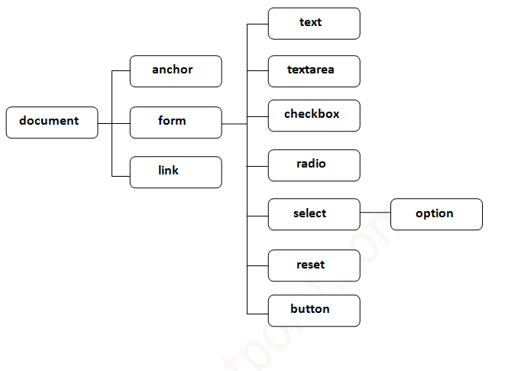

## Methods of document object

We can access and change the contents of document by its methods.

The important methods of document object are as follows:

|  |  |
| --- | --- |
| **Method** | **Description** |
| write("string") | writes the given string on the doucment. document.write(“string”); |
| writeln("string") | writes the given string on the doucment with newline character at the end. |
| getElementById() | returns the element having the given id value. |
| getElementsByName() | returns all the elements having the given name value. |
| getElementsByTagName() | returns all the elements having the given tag name. |
| getElementsByClassName() | returns all the elements having the given class name. |

### Accessing field value by document object

In this example, we are going to get the value of input text by user. Here, we are using **document.form1.name.value** to get the value of name field.

Here, **document** is the root element that represents the html document.

**form1** is the name of the form.

**name** is the attribute name of the input text.

**value** is the property, that returns the value of the input text.

Let's see the simple example of document object that prints name with welcome message.

**<script** type="text/javascript"**>**

function printvalue(){

var name=document.form1.name.value;

alert("Welcome: "+name);

}

**</script>**

**<form** name="form1"**>**

Enter Name:**<input** type="text" name="name"**/>**

**<input** type="button" onclick="printvalue()" value="print name"**/>**

**</form>**

# Location Object

The location object contains information about the current URL.

The location object is part of the window object and is accessed through the window.location property.

## Location Object Properties

|  |  |
| --- | --- |
| **Property** | **Description** |
| [hash](https://www.w3schools.com/jsref/prop_loc_hash.asp) | Sets or returns the anchor part (#) of a URL |
| [host](https://www.w3schools.com/jsref/prop_loc_host.asp) | Sets or returns the hostname and port number of a URL |
| [hostname](https://www.w3schools.com/jsref/prop_loc_hostname.asp) | Sets or returns the hostname of a URL |
| [href](https://www.w3schools.com/jsref/prop_loc_href.asp) | Sets or returns the entire URL |
| [origin](https://www.w3schools.com/jsref/prop_loc_origin.asp) | Returns the protocol, hostname and port number of a URL |
| [pathname](https://www.w3schools.com/jsref/prop_loc_pathname.asp) | Sets or returns the path name of a URL |
| [port](https://www.w3schools.com/jsref/prop_loc_port.asp) | Sets or returns the port number of a URL |
| [protocol](https://www.w3schools.com/jsref/prop_loc_protocol.asp) | Sets or returns the protocol of a URL |
| [search](https://www.w3schools.com/jsref/prop_loc_search.asp) | Sets or returns the querystring part of a URL |

## Location Object Methods

|  |  |
| --- | --- |
| **Method** | **Description** |
| [assign()](https://www.w3schools.com/jsref/met_loc_assign.asp) | Loads a new document |
| [reload()](https://www.w3schools.com/jsref/met_loc_reload.asp) | Reloads the current document |
| [replace()](https://www.w3schools.com/jsref/met_loc_replace.asp) | Replaces the current document with a new one |